Validation Programe User Guide

1. Introduction

This programe is used for validate the login for a user to the devices in one office.

1. System and software requirements

* Windows PC
* ActiveTcl (version 8.5.18.0, windows (x86)), 64-bit version is not recommend
* Validation.tcl script
* plink.exe

1. Installation of ActiveTcl
   1. Download ActiveTcl in <http://www.activestate.com/activetcl/downloads>
   2. Choose stable version 8.5.18.0 Window (x86), no matter your PC is 64-bit version.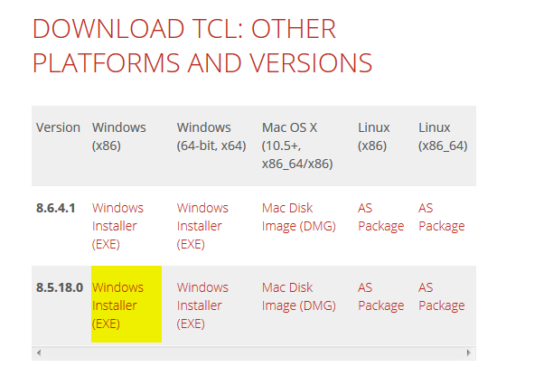
   3. Double click the executed file and start installation. 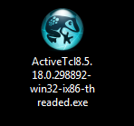
   4. Click “**Next**”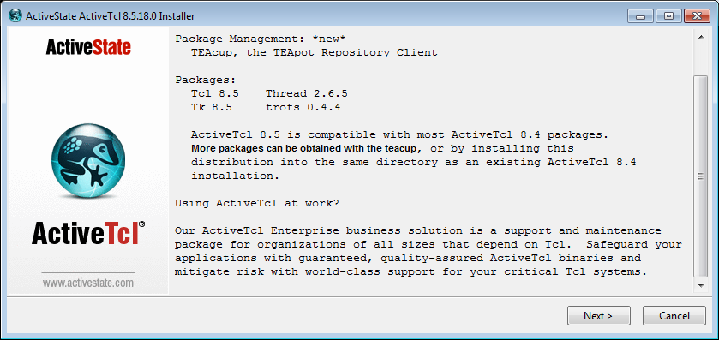
   5. Select “**I accept the terms in the License Agreement**” and click “**Next**”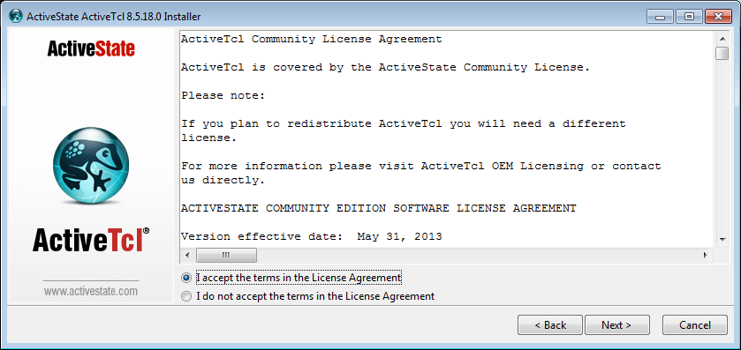
   6. Keep default selection and click “**Next**” 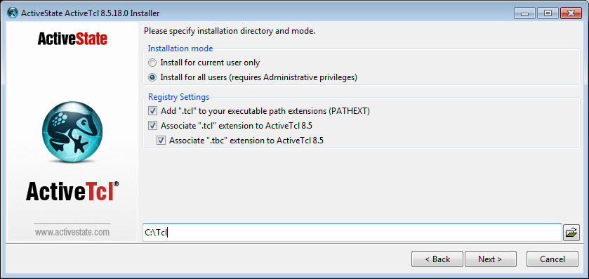
   7. Click “**Next**”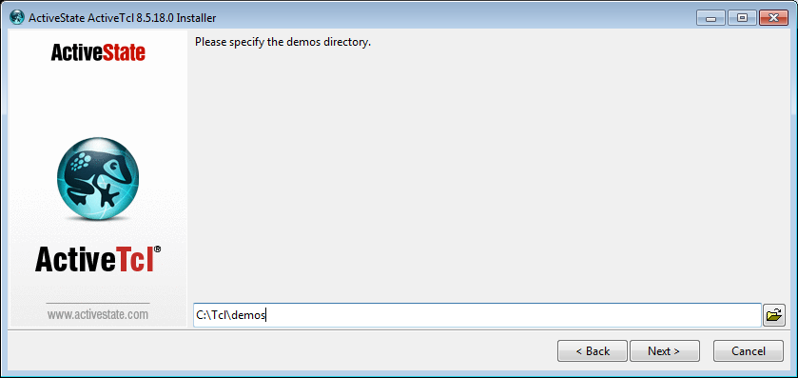
   8. Click “**Next**”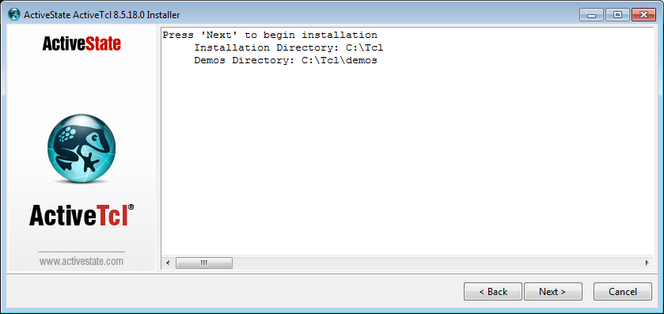
   9. Click “**Finish**”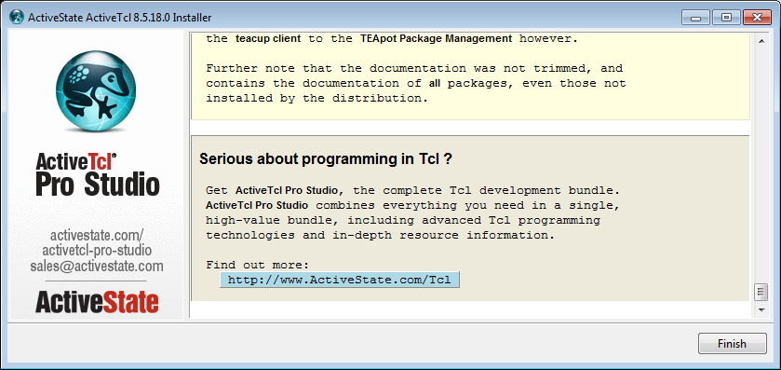
   10. Verify your installation. Open cmd.exe and type “**tclsh**” and press “Enter”, if the “**%**” character appears in the command prompt, then the installation successfully. The installation directory is typically @ **c:/Tcl** .
   11. Use the Tcl Extension Archive client –Teacup to install the Expect script package. Type in “**teacup install Expect**” and press “Enter”.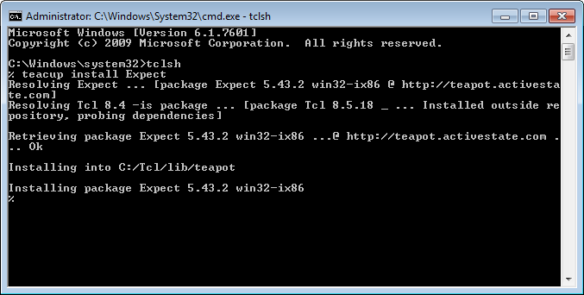
   12. Verify the installation of the Expect package, re-type the command above, found that “**Already installed**”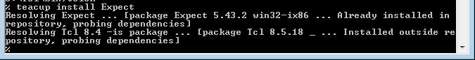
   13. Done.
2. Download **plink.exe** programe ( <http://www.chiark.greenend.org.uk/~sgtatham/putty/download.html> )

and save it in the **same** directory as the **validation.tcl**

1. Validation programe
   1. Open **cmd.exe** and “**cd**” to the directory of the **validation.tcl**. Make sure the plink.exe and validation.tcl are in the same directory. 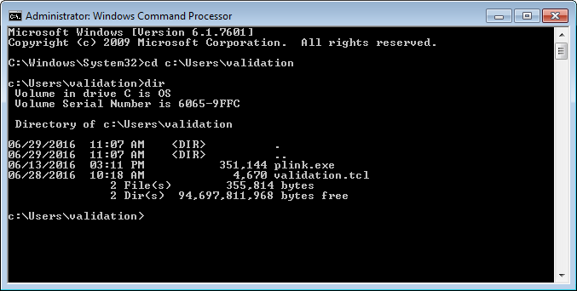
   2. To run the validation programe, Type in

“**tclsh validation.tcl <office code> <user name> <password>**”

and press “**Enter**”. In this example, replace the **“<office code>”** as “**testmain**”, “**<user name>**” as “**mainlev**”, and “**<password>**” as “**DHHresR5**” for demonstration.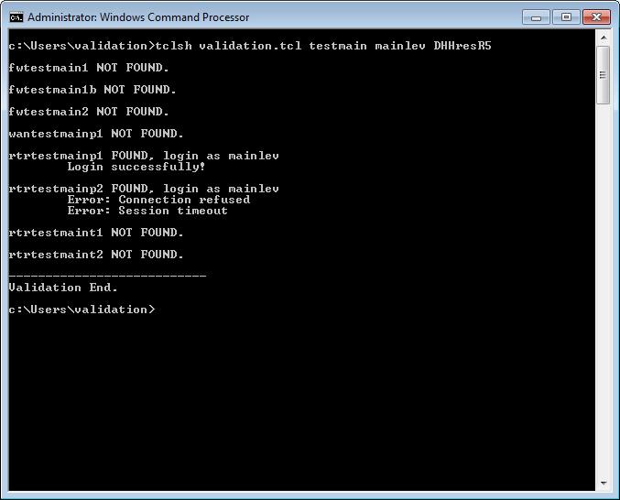

* 1. As the output of the result, the programe would tell you two types of information, one is the existence of the devices in the office, and second one the login validation of this user.
  2. If the device exists in the office, the “**FOUND**” would be output, otherwise “**NOT FOUND**” would be shown.
  3. If the login is validated by this user, the “**Login successfully!**” would be shown, otherwise it would be shown some types of error messages such as

“**Error: Authentication failed! Login again**” and “**Error: Incorrect username or password.**”

* 1. The **validation.tcl** programe had been controlled to avoid locking account as only 3-time login trials would implement.